## Functionality testing

| Test Number | Test Type | Expected Results | Actual Result |
| --- | --- | --- | --- |
| 1 | Navigation Functionality | All navigation links direct the user to the correct pages. | Achieved |
| 2 | Form Validation | Contact form prevents submission if required fields are empty or invalid input is provided. | Achieved |
| 3 | CV Download | Clicking the CV download link initiates a download of the correct PDF file. | Download PDF wouldn’t work due to a ‘non-existent path’ message. On investigation I noticed I’d used a quote mark in an incorrect place in the HTML |
| 4 | Social Media Links | Footer links redirect to the correct social media sites. | Achieved |
| 5 | Responsive Design | Website layout adjusts seamlessly on various screen sizes (mobile, tablet, desktop). | While good I wouldn’t say seamlessly. The padding on the navigation buttons spreads a little too much and the pigeon picture can become too small. At this stage I’d identify them as possible future improvements. |

## User testing

| Test Number | Test Type | Expected Results | Actual Result |
| --- | --- | --- | --- |
| 1 | Navigation Functionality | All content is easily readable and visually appealing across devices. | Achieved, although there is room for improvements in terms of visual appeal. A potential future development. |
| 2 | Form Validation | Users receive clear feedback if they haven't successfully filled in the form. | Achieved |
| 3 | CV Download | All pages load within a second. | Achieved |
| 4 | Alt tag | When the picture isn’t visible the alt tag displays | Achieved |

### User Story as an Employer

| Test Number | Test Intention | Test Nature | Actual Result |
| --- | --- | --- | --- |
| 1 | I want to quickly access a candidate's qualifications and skills so I can evaluate their suitability for a role. | Navigate to the Resume page and ensure the qualifications and skills are clearly listed | Achieved  See screen US-E1 |
| 2 | I want to open the candidate's CV to potentially share with my team | Click the CV open link and verify that the file is viewable | Achieved  See screen US-E2 |
| 3 | I want to contact the candidate directly with questions or job offers. | Use the contact form and verify that a that a partially complete email client opens after submission | This has worked previously, however I’ve had an error message about opening the same client too many times and I really don’t want to explore the solution of clearing my cookies this close to the submission deadline! |

**Screens**

**US-E1**

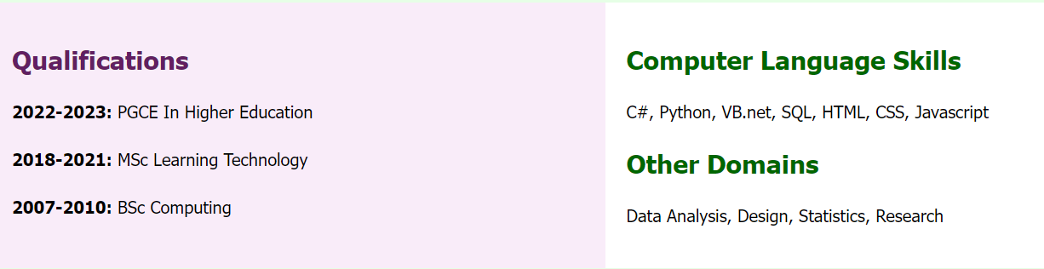

**US-E2**

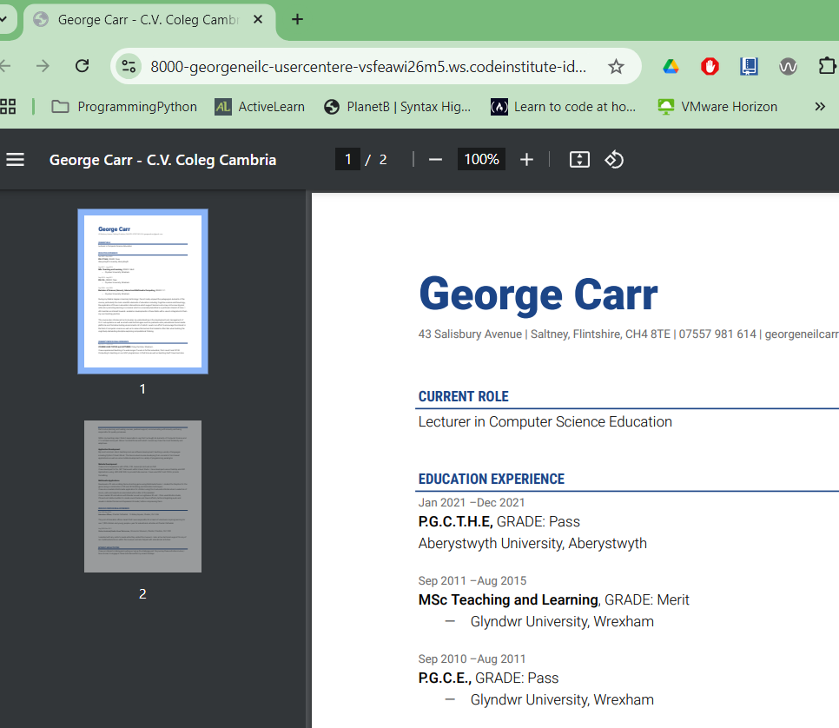

**US-E3**

### User Story of a Networking Contact

| Test Number | Test Intention | Test Nature | Actual Result |
| --- | --- | --- | --- |
| 1 | I want to find links to the candidate's social media profiles for professional networking | Click the links in the footer and ensure they direct to the correct profiles | See screen US-E1 |
| 2 | I want to view a brief overview of the candidate's background and interests | Navigate to the Home page and verify the information is displayed correctly | Achieved, although it is *rather* brief.  US-E2 |

**Screens**

**US-E1**

**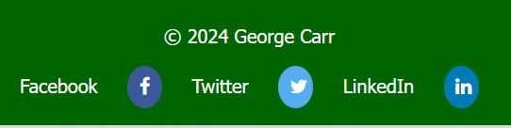  
After Clicking Facebook**

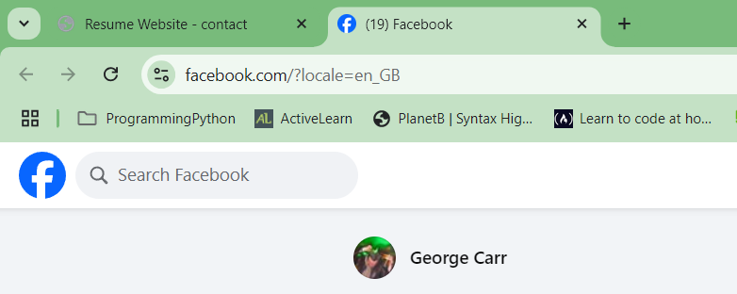

**US-E2**

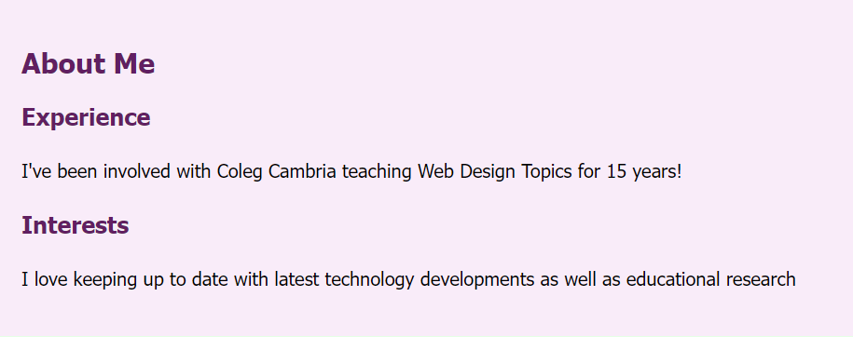

### User Story a General User

| Test Number | Test Intention | Test Nature | Actual Result |
| --- | --- | --- | --- |
| 1 | I want the website to display properly on my device, regardless of screen size | Resize the browser window or view the site on different devices to ensure responsive design functions correctly | See screens US-G1 and US-G2 |
| 2 | I want to easily navigate between pages to explore the site | Click on the navigation links and verify that each page loads as expected | Achieved  US-G3 |

**Screens**

**US-G1**

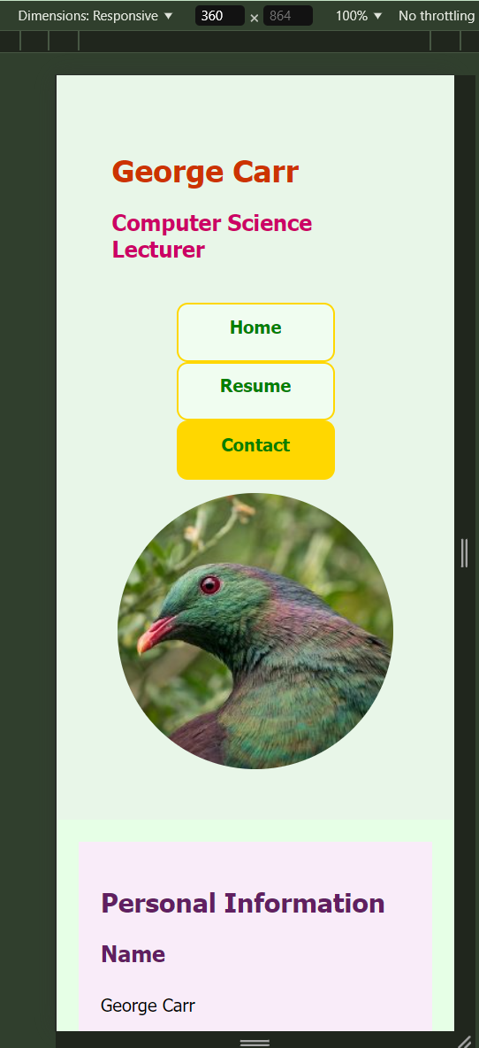

**US-G2**

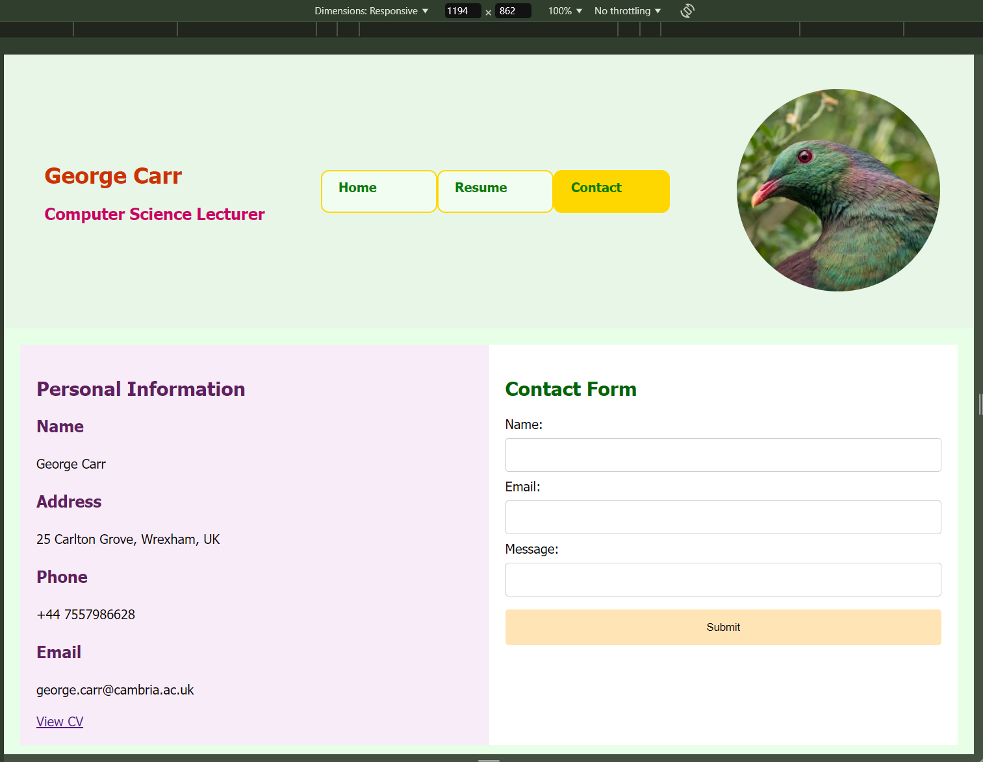

**US-G3 - After Clicking “Contact”**

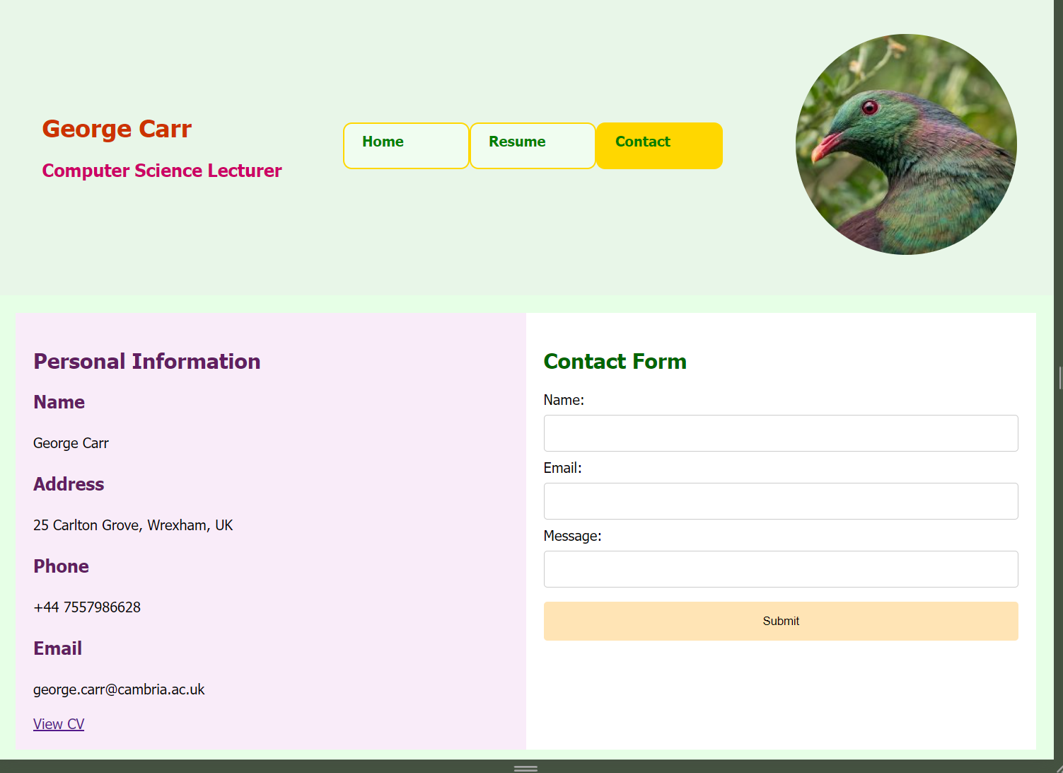

### Validation Tests

CSS, And HTML tests for the Home Page were fine the first time.

For the Resume HTML page I had the error below

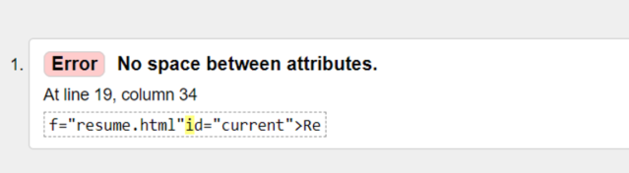

This was a simple fix by finding the line and adding a space mark in the correct place.

For Contact HTML I had the following errors

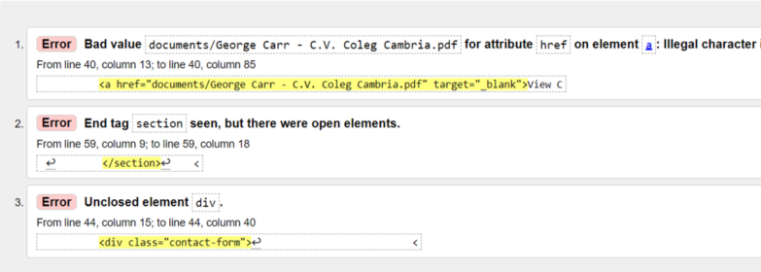

The PDF CV was an issue as I’d included space in the filename. I changed the name of the asset to fix that.

Errors 2 and 2 were both fixed by closing the open div tag correctly.